4. If heat (Q) is transformed to or from the surrounding OR if work (W) is done or by surrounding on the system, then from 1st law of thermodynamics:

$$δQ − δW = dE$$

or

$$\dot{Q} − \dot{W}$$ (4)

Eq (4) is a scalar equation.

Ex. Work extracted by turbine from a gas stream.

5. The 2nd law of thermodynamic, Eq(5) should be obeyed:

$$ds ≥ \frac{SQ}{T}$$ (5)

Ds is the entropy and T is the temperature.

Note: Not very practical in fluid Dynamics, unless you are studying details of flow loss.

(equations)

NOTE: In general flow velocity id a vector, i.e. variable in time and space:

V(x,y,z,t) = $$i u\left(x,y,z,t\right)+j v\left(x,y,z,t\right)+k w\left(x,y,z,t\right)$$

Where, $$V_{x}=u\left(x,y,z,t\right)$$

$$V_{y}=v\left(x,y,z,t\right)$$

$$V_{z}=w\left(x,y,z,t\right)$$

And acceleration of flow (a) is: a= $$\frac{dV}{dt}$$

$$a = \frac{∂v}{∂t}+u\frac{dv}{dx}+v\frac{∂v}{∂y}+w\frac{∂v}{∂z}$$“total differential”

Question – How to use differential equations above to do a central velocity level analysis?

Answer - $$RTT^{2}$$

RTT may be different in form depending on, if:

1. c.v. is fixed  
   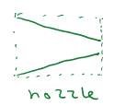
2. c.v. is moving  
   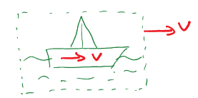
3. c.v. is deformable  
   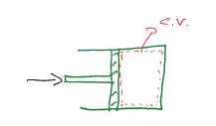
4. Fixed c.v.

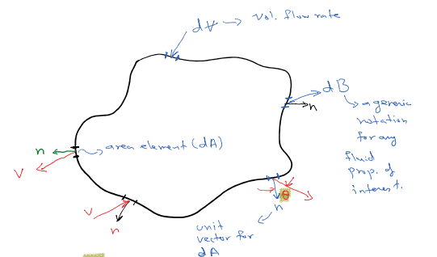

$$d∀ = VdA \cos\left(θ\right)dt$$

v . N= VdAcos(theta)

dt – at a given instant

cos (theta) - will determine if flow is in pr out to c.v.

theta = 90: flow is along the streamline

-90 < theta < 90 out flow

90 < theta < 270 in flow

We can extend the above concept to any intensive fluid property (denoted by B). Note B can be a scalar or a vector.

Aside intensive property is one that its value does not depend on the mass

(e.g. vel.). so: $$β = \frac{dB}{dm}$$ (7)

where, dB – amount of B in an element

dm – mass of the element

From equation (6): $$dm = ρd∀ = ρVcosθdtdA ⇒ dm = ρ\overline{V}⋅ndtdA$$ (8)

From equation (7) & (8): $$\frac{dB}{dt}=βρVdAcosθ = βρ\overline{V}∙ndA$$ (9)

Equation (9) represents the elemental flux rate of property B into /out of c.v. crossing the C.S.

$$\int_{cs}^{⍁}{dBdt}≡ the net fluc rate of B \frac{into}{out of c.v. }≡\int_{c.s.}^{β}{ρ\overline{V}}∙ndA$$ (10)

$$\int_{cs}^{⍁}{dBdt}≡\int_{cs}^{β}{βV}cosθdA_{out}−\int_{cs}^{β}{ρV}cosθdA_{in}$$ (10a)

Equation (10a) is the practical form of Equation (10).

Conservation law mean that: $$\frac{dBsys}{dt}=\frac{d}{dt}\int_{c.v}^{∙}{dB}+\int_{c.s.}^{∙}{dBdt}$$ (11)

where, rate of change of B within the Vel. - $$\frac{d}{dt }\int_{c.v}^{∙}{db}$$

And flux rate in/out of c.v is : $$\int_{c.s}^{⍁}{dbdt}$$

Aside from equation (7): $$db = ρβd∀$$ (12)

From equations 10 –12:

$$\frac{d}{dt}\left(B_{sys }\right) = \frac{d}{dt}\int_{cv}^{∙}{βρd}∀ + \int_{c.s}^{⋅}{βρ\overline{V}}ndA$$ (13)

$$∴$$ Eq(13) is the RTT relating the time derivative of a property (B) to the c.v. level properties!

So we can do system level (integral) fluid mechanics for equations 1 – 4 without the need for knowing the flow details at every point of c.v.

Goals (lect 5):

1. Review of Reynolds Transport Theorem (very fast!)
2. Solve problems
3. Bernoulli Eq

Example 1: Water enters a short conduit at a vel of 10 m/s as shown below. What is the water vel at exit?

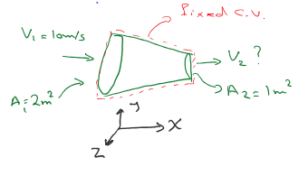

$$β≡m$$

$$β = \frac{m}{m}=1$$

From equation (1) : $$\frac{dm}{dt}$$

Assume flow at inlet and outlet are 1D flow (i.e main in x-direction). Assume water is incompressible

( $$ρ = const$$)

Assume the flow is steady state, so V is constant in time

Eq (13): d/dt ~~(B_sys)~~

Example 2: Find an expression for the rate of change of height shown in figure below:

The issue is the mass of water in the tank ($$\left(m_{w} = ρ_{m}A_{t}h\right) = B_{sys} = m_{w}$$

Where $$ρ_{m and A_{t} }$$ are constants

$$β = \frac{dm}{dm} = 1$$

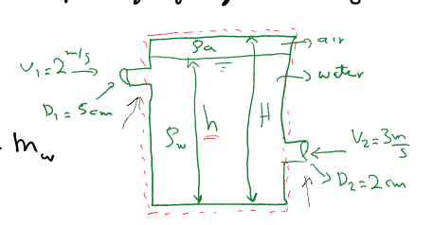

From eq (13): $$\frac{dm}{dt}= \frac{d}{dt}\int_{cv}^{⋅}{ρd}∀ + \int_{cs}^{⋅}{ρ_{w\overline{V\overline{n}}}}dA$$

From eq(1): $$\frac{dm}{dt}= 0$$ $$→ \frac{d}{dt}\int_{cv}^{∙}{ρd}∀ + \int_{cs}^{∙}{ρ_{w}} \overline{Vn}dA = 0$$

$$\frac{d}{dt}\int{}⋅^{⋅}ρA_{t}dh − \int{}∙^{∙}ρ_{w}V_{1}dA_{1} − \int{}∙^{∙}ρ_{w}V_{2}dA_{2} = 0$$

In flows : $$\int{}∙^{∙}ρ_{w}V_{1}dA_{1}$$

$$\frac{d}{dt}\left[\int_{o}^{h}{ρ_{w}}A_{t}dh →\int_{h}^{H}{ρ_{a}}A_{t}dh\right] − ρ_{w}\left(V_{1}A_{1}+V_{2}A_{2}\right) = 0$$

$$\frac{d}{dt}\left[ρ_{w}A_{t}h →ρ_{a}A_{t}\left(H−h\right)\right] = ρ_{w}\left(V_{1}A_{1}+V_{2}A_{2}\right)$$

Mass of air trapped: $$ρ_{a}A_{t}\left(H−h\right)$$

$$ρ_{w}A_{t} \frac{dh}{dt} + \frac{d}{dt}\left[ρ_{a}A_{t}\left(H−h\right)\right] ⇒ \frac{dh}{dt} = \frac{piR_{1}^{2} x 2 + piR_{2}^{2} x 3}{2} = 0.01 \frac{m}{s}$$

2 – Moving C.V

If c.v. is moving at vel., Vs., and observer fixed to the c.v., sees a relative vel. ( V_r) of fluid crossing the c.v

$$V_{r}= V − V_{s}$$, where V_r is the relative vel of fluid, V is the fluidal absolute and V_s is the c.v. absolute velocity.

RTT will have the form of Eq (13), just replace V with V_r

Note: V_s may be a constant, or a function time (variable vel) , V_s(t), which means V_r can be a constant, or a function of time, I.e, V_r(t), respectively.

$$\frac{dB_{sys}}{dt}= \frac{d}{dt}\int_{cv}^{∙}{βρd}∀ +\int_{cs}^{∙}{βρ\left(\overline{V_{r}} ∙ \overline{n}\right)dA}$$ (14)

3 – Deforming & moving c.v

If c.v is deforming & moving, then $$\overline{V_{s}}\left(\overline{r}, t\right)$$ [Vector of space], so $$\overline{V_{r}}\left(\overline{r}, t\right)$$.

Again the form of RTT eq. Doesn't change from eq (14), but it’s integration becomes more complicated... you may need to use Matlab to solve the integral.

In Ex. 2, one could have chosen c.v as shown below:

Still mass (m) is of interest

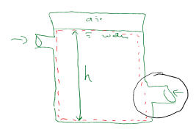

$$β = 1$$

$$\frac{d}{dt}\int_{cv}^{∙}{ρ_{w}}d∀ + \int_{cs}^{∙}{ρ_{w\overline{V_{r}}}}∙\overline{n} dA = 0$$

Notice although with time, the top surface od c.v moves (I.e. cv deforms), but surface where there is flow/flux (inlets ans outlets) placed stay stationary in time, so V_s = 0, and V_r will be the same as V, so....

$$\frac{d}{dt}\left[ρ_{w}A_{t}h\right] = ρ_{w}\left(A_{1}v_{1}+A_{2}V_{2}\right)…… same \frac{dh}{dt}= 0.01 \frac{m}{s}$$

Example 3: What is the magnitude of F and its angle w.r.t horizon ( $$φ$$); id a fluid jet impacts the value as shown. No friction as pressure change exists.

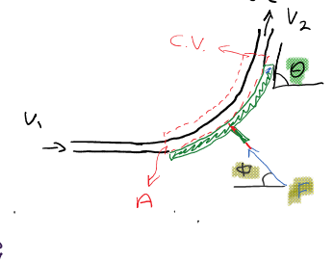

Assumption:

1. Incomplete flow
2. Steady state
3. The jet doesn’t expand as travels over the vane
4. No losses

$$\overline{F} = \frac{d}{dt}\left(m\overline{v}\right)$$

13 will be $$m\overline{v} → so β = \frac{m\overline{v}}{m} = \overline{V}$$

The c.v is defined as a fixed c.v. are eq 13

$$F = \frac{d}{dt}\int_{cv}^{∙}{ρ\overline{V}}d∀ + \int_{cs}^{⋅}{ρ\overline{V}} \overline{V} ⋅ndA$$

Note we do not consider friction on the cane, so V_1 = V_2 = V

$$F = −ρ\overline{V_{1}}V_{1}A_{1} + ρ\overline{V_{2}} \overline{V_{2}} A_{2}$$ [ - : inflow, + : outflow](note: in = $$\left(V=V_{1}=V_{2}\right)ρ\left(A=A_{1}=A_{2}\right)$$)

$$\overline{F} − in\left(\overline{V_{2}}−\overline{V_{1}}\right) ⇒ F_{x }= in \left(V_{2}\cos{θ}−V_{1}\right) = in V\left(\cos{θ}−1\right)$$

$$⇒ F_{y}= in \left(V_{2}sinθ−0\right) = in Vsinθ$$ (theta that jet exists the vane)

$$\left|F\right| = \sqrt{F_{x}^{2}+F_{3}^{2}}= 2in V \frac{sinθ}{2}$$

$$tanφ = \frac{F_{y}}{F−x}= \frac{in Vsinθ}{inV\left(cosθ−1\right)}= \frac{sinθ}{cosθ−1}⇒φ=\tan^{−1}\left(\frac{sinθ}{cosθ−1}\right)$$

Example 4: What is the drag force on a wing with dimensions (bxl) in a steady state air flow?

1. Let’ simply the wing is a flat plate
2. Let's assume flow is 1D in x-direction

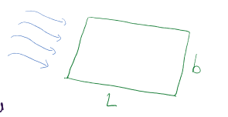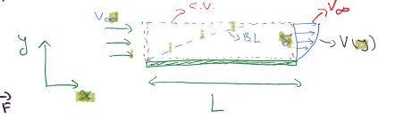

We know that a boundary ;ayer (B.L) will form and grow on a plate exposed to V_infinity (See fig above)

$$β = mV →β=V$$

Eq (2) $$\frac{db_{sys}}{dt}= \frac{dm\overline{V}}{dt}= \overline{F}$$

$$\overline{F} = \frac{d}{dt}\int_{cv}^{∙}{Vρd}∀ +\int_{cs}^{∙}{Vρ\overline{V}}∙\overline{n} dA \& da = bdy$$

$$\overline{F} =\int_{0}^{δ}{Vρ\overline{V}}∙\overline{n} bdy$$

$$F=−∫_0^δv_∞ρv_∞b dy ├|_\{x =0\} + ∫_0^δρV├(y┤)^2bdy┤|_\{x = L\}$$

$$F=−\int_{0}^{δ}{V_{∞}}ρv\left(y\right)bⅆy ├_{x =L}+{\left.\int_{0}^{δ}{ρV{\left(y\right)}^{2}}bdy\right|}_{x=L}$$

F = - D (drag)

$$d = ρB\int_{0}^{δ}{V\left(y\right)\left[V_{∞}− V\left(y\right)\right]dy├_{x=L}}$$

$$D α \left[V_{∞}−V\left(y\right)\right]$$

Vel. Deficit created by the B.L. is the physical origin of the drag force!

Van Karman derived this relationship in 1921!

Sec. 3.5 Bernoulli Eq.

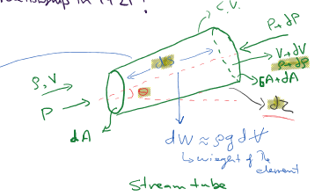 Will not consider stream stress on the wall, so ONLY frictionless flow

Writing RTT for momentum Eq (2):

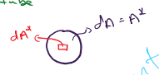

$$d\overline{F} = \frac{d}{dt}\int_{cv}^{∙}{}\overline{V} ρ d∀ + \int_{cs}^{∙}{}\overline{V} ρ \overline{V∙n} dA$$

And element of an infinitesimal section: $$d∀ ⇒ s^{∗}= ds$$

$$d∀ ≈dadS$$

$$A^{∗}= dA$$

Along the streamline - $$dF_{s}= \frac{d}{dt}\int_{s}^{⋅}{V_{s}}ρdAds^{∗}−\int_{cs}^{∙}{V_{s}}ρV_{s}dA^{∗}+\int_{cs}^{∙}{\left(V_{S}+dV_{s}\right)ρ\left(V_{s}+dV_{s}\right)dA^{∗}}\}$$

(Integrate over starred variables)

$$dF_{s }= \frac{∂V_{S}}{∂t}ρdAds + \frac{∂ρ}{∂t}V_{s}dads − V_{s}din_{in}+V_{s}din_{out}+dV_{s}din_{out}+V_{s}\left(din_{out}−din_{in}\right)$$

$$dF_{s}≈\frac{∂V_{s}}{∂t}ρdρAds + \frac{∂ρ}{∂t}V_{s}dAds + V_{s}din^{∗}+dV_{s}din$$

These terms - $$\frac{∂ρ}{∂t}V_{s}dAds + V_{s}din^{∗}$$, due to massconservation the terms cancel each other out, see Eq(1)

On the other hand, forces on stream tube element are pressure & gravity

So ,

- for an small angled tube, approx dpdA

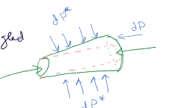

$$dF_{s}≈−ρgdAdz − dpdA$$

$$−ρgdAdz − dpdA = \frac{∂V_{s}}{∂t}ρdAds + dindV_{s}$$, $$din⇒ρV_{s}dA$$

$$\frac{∂V_{s}}{δt}ds + \frac{dp}{ρ}+V_{s}dV_{s} + gdz = 0$$ (15)

Eq(15) is unsteady frictionless along a stream tube (to write for a stream line, we put stream on a diet!)

If we consider flow is steady state, then $$\frac{∂V_{s}}{δt}= 0$$

If “ “ fluid to be incompressible ($$ρ = const$$), then I can simply write dP = P2-P1 : decpupling P&P

So, integrating between 2 points, 1 & 2:

$$\frac{P_{1}−P_{1}}{ρ}+\frac{1}{2}\left(V_{2}^{2}−V_{1}^{2}\right)+g\left(Z_{2}−Z_{1}\right) = 0$$ (16)

NOTE: In deriving Eqs. 15 ^ 16, we used conservation of mass & momentum. But not conservation of enerygy ! => So, if heat or work are added/renewal from c.v., then there Eqs (15 & 16) are not applicable.

DO NOT use!

Observations:

From 16: $$\frac{P_{1}}{ρ}+ \frac{1}{2}V_{1}^{2} + gZ_{1}= const$$

$$\frac{P_{1}}{gρ}+\frac{1}{2} \frac{V_{1}^{2}}{g}+ Z_{1}= H \left(Head\right)$$

See fig 3.13

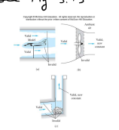 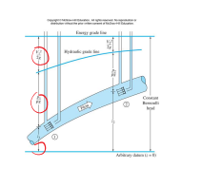

2.If the change in Z is negligible, then Eq (16):

$$\frac{P_{1}}{gρ}+\frac{1}{2} ρV_{1}^{2}= const = P_{0}$$, take a look at the exp. 3.16 in the text book.

Sec. 3.6 - Angular Momentum Theorem:

In system, like pumps; turbines where flow rotates, the linear may not be very useful for analysis. Also, angular that there is a miss-alignment between fluid dlow and force line of action.

Note a fluid is deformable unlike a solid, so angular momentum should be written on elemental basis;

So,

$${\overline{H}}_{0}=\int_{sys}^{∙}{\left(\overline{r} x \overline{v}\right)} dm$$ (17)

$$β = \frac{d\overline{H_{0}}}{dm} = \overline{r} x \overline{v}$$

From RTT

$$\frac{d\overline{H_{0}}}{dt}├_{\{_{sys}} = \frac{∂}{∂t}\int_{cv}^{∙}{\left(\overline{r} x \overline{v}\right)ρd}∀ +\int_{cs}^{∙}{\left(\overline{r} x \overline{v}\right)ρ\left(\overline{v}∙\overline{n}\right)dA}$$

From mechanics, we know: $$\frac{d\overline{H_{0}}}{dt}= \sum_{ }^{ }{M_{o}} = \sum_{ }^{ }{\left(\overline{r }x \overline{F}\right)}$$

$$\sum_{ }^{ }{M_{o}} ⇒$$ Summation of moment for all forces (gravity, pressurem etc.) around O

$$\sum_{ }^{ }{M_{o}} = \frac{∂}{∂t}\int_{cv}^{∙}{\left(\overline{r} x \overline{v}\right)ρd}∀ + \int_{cs}^{∙}{\left(\overline{r} x \overline{v}\right)ρ\left(\overline{v}∙\overline{n}\right)dA}$$ (18)

Most patterns can be treated as 1D inlet/outlet and analyzed in steady conditions

So:

$$\sum_{ }^{ }{M_{o}} = \sum_{ }^{ }{{\left(\overline{r} x v\right)}_{out}}in_{out} − \sum_{ }^{ }{{\left(\overline{r} x \overline{v}\right)}_{in}}in_{in}$$ (19)

Otherwise, ore must use differential approach (see chap 4), and use computers to solve Eqs. Numerically.

Sec 3.7 - Energy Eq.

This is our 4th law to consider

Energy (e) has several forms:

$$e_{internal}\left(α U\right), e_{kinematic}\left(α \frac{1}{2}mv^{2}\right)$$ r_2

$$e_{potential}\left(α mgz\right)$$, and many others chem, elec,…

Usually are deal with the 1st 3 types:

* Work (w) can usually have 3 forms: $$w_{shaft}, w_{press}, w_{viscos}$$

$$w_{press} → w_{p}= \frac{dw_{p}}{dt} = p\left(\overline{v}∙\overline{n}\right) dA$$

$$w_{viscos} → w_{v}= \frac{dw_{v}}{dt} = −τ\overline{v}dA$$

The heat (Q) has normally 3 forms: $$Q_{conv}, Q_{cord} , Q_{rad}$$ but in this course we mainly deal with isothermal flows ( no details for heat transfer)

Using RTT with $$β = u^{∧} +\frac{1}{2 }v^{2}+ gz$$

$${\frac{dE}{dt}}_{sys}=\dot{Q \dot{W_{s}}}− \dot{W_{v}} = \frac{∂}{∂t}\int_{cv}^{∙}{\left(u^{∧}+\frac{1}{2 }v^{2}+gz\right)} ρ d∀+ \int_{cs}^{∙}{\left(h+\frac{1}{2}v^{2}+gz\right)ρ\left(v^{→}∙n^{→}\right)dA}$$

Where h is the enthalpy = $$\frac{P}{ρ}+u^{∧}$$ ($$ρ$$- press. Work brought from LHS to RHS)

For steady, 1D flow:

$$\dot{Q} − \dot{W_{s}} − \dot{W_{v}} = \sum_{ }^{ }{{\left(h+\frac{1}{2 }v^{2}+ gz\right)}_{out}}in_{out} − \sum_{ }^{ }{{\left(h+\frac{1}{2}v^{2}+gz\right)}_{in}}in_{in}$$

( $$\left(h+\frac{1}{2}v^{2}+gz\right)$$- - evaluate as an average over the in/out area)

Example 3.18 :

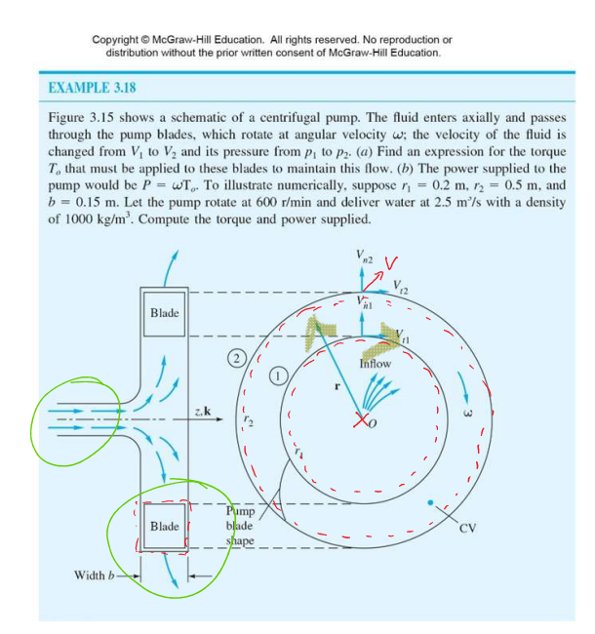

1. Pay attention to how the c.v is selected to make the analysis a simple flow in -> flow out problem
2. No need to consider pressure as lfluid passes through “O”, no momentum is generated
3. The same as 2 is true for normal component of velocity vector
4. Assume 1D flow due to defined c.v., then use Eq.18

$$\sum_{ }^{ }{M_{0}} = T_{0} = \left(r_{2}^{→} x v_{2}^{→}\right)in_{out} − \left(r_{1}^{→} x v_{1}^{→}\right)in_{in}$$ (where T is the torque) (I)

Steady flow: $$in_{in} = ρV_{n1}2 Πr_{1}b = in_{out} = ρV_{n2}2 Πr_{2}b = ρQ$$

$$r_{2}^{→} x v_{2}^{→} = r_{2}V_{t2}\sin\left(90\right) k^{∧}$$ (clockwise)

$$r_{1}^{→} x v_{1}^{→} = r_{1}V_{t1}K$$

From (I) : $$T_{0 }= ρQW \left(r_{2}^{2} − r_{1}^{2}\right)$$ (clockwise)

Knowing that $$v_{t1} = wr_{1} \& v_{t2} = wr_{2}$$

$$T_{0} = ρQW \left(r_{2}^{2} − r_{1}^{2}\right)$$ clockwise - Euler equation of pump

DO PART (b) ON YOUR OWN